Appendix G - Coding Agents

# Vibe Coding: A Starting Point

"Vibe coding" has become a powerful technique for rapid innovation and creative exploration. This practice involves using LLMs to generate initial drafts, outline complex logic, or build quick prototypes, significantly reducing initial friction. It is invaluable for overcoming the "blank page" problem, enabling developers to quickly transition from a vague concept to tangible, runnable code. Vibe coding is particularly effective when exploring unfamiliar APIs or testing novel architectural patterns, as it bypasses the immediate need for perfect implementation. The generated code often acts as a creative catalyst, providing a foundation for developers to critique, refactor, and expand upon. Its primary strength lies in its ability to accelerate the initial discovery and ideation phases of the software lifecycle. However, while vibe coding excels at brainstorming, developing robust, scalable, and maintainable software demands a more structured approach, shifting from pure generation to a collaborative partnership with specialized coding agents.

# Agents as Team Members

While the initial wave focused on raw code generation—the "vibe code" perfect for ideation—the industry is now shifting towards a more integrated and powerful paradigm for production work. The most effective development teams are not merely delegating tasks to Agent; they are augmenting themselves with a suite of sophisticated coding agents. These agents act as tireless, specialized team members, amplifying human creativity and dramatically increasing a team's scalability and velocity.

This evolution is reflected in statements from industry leaders. In early 2025, Alphabet CEO Sundar Pichai noted that at Google, **"***over 30% of new code is now assisted or generated by our Gemini models, fundamentally changing our development velocity.*Microsoft made a similar claim. This industry-wide shift signals that the true frontier is not replacing developers, but empowering them. The goal is an augmented relationship where humans guide the architectural vision and creative problem-solving, while agents handle specialized, scalable tasks like testing, documentation, and review.

This chapter presents a framework for organizing a human-agent team based on the core philosophy that human developers act as creative leads and architects, while AI agents function as force multipliers. This framework rests upon three foundational principles:

1. **Human-Led Orchestration:** The developer is the team lead and project architect. They are always in the loop, orchestrating the workflow, setting the high-level goals, and making the final decisions. The agents are powerful, but they are supportive collaborators. The developer directs which agent to engage, provides the necessary context, and, most importantly, exercises the final judgment on any Agent-generated output, ensuring it aligns with the project's quality standards and long-term vision.
2. **The Primacy of Context:** An agent's performance is entirely dependent on the quality and completeness of its context. A powerful LLM with poor context is useless. Therefore, our framework prioritizes a meticulous, human-led approach to context curation. Automated, black-box context retrieval is avoided. The developer is responsible for assembling the perfect "briefing" for their Agent team member. This includes:
   * **The Complete Codebase:** Providing all relevant source code so the agent understands the existing patterns and logic.
   * **External Knowledge:** Supplying specific documentation, API definitions, or design documents.
   * **The Human Brief:** Articulating clear goals, requirements, pull request descriptions, and style guides.
3. **Direct Model Access:** To achieve state-of-the-art results, the agents must be powered by direct access to frontier models (e.g., Gemini 2.5 PRO, Claude Opus 4, OpenAI, DeepSeek, etc). Using less powerful models or routing requests through intermediary platforms that obscure or truncate context will degrade performance. The framework is built on creating the purest possible dialogue between the human lead and the raw capabilities of the underlying model, ensuring each agent operates at its peak potential.

The framework is structured as a team of specialized agents, each designed for a core function in the development lifecycle. The human developer acts as the central orchestrator, delegating tasks and integrating the results.

## Core Components

To effectively leverage a frontier Large Language Model, this framework assigns distinct development roles to a team of specialized agents. These agents are not separate applications but are conceptual personas invoked within the LLM through carefully crafted, role-specific prompts and contexts. This approach ensures that the model's vast capabilities are precisely focused on the task at hand, from writing initial code to performing a nuanced, critical review.

**The Orchestrator: The Human Developer:** In this collaborative framework, the human developer acts as the Orchestrator, serving as the central intelligence and ultimate authority over the AI agents.

* + **Role:** Team Lead, Architect, and final decision-maker. The orchestrator defines tasks, prepares the context, and validates all work done by the agents.
  + **Interface:** The developer's own terminal, editor, and the native web UI of the chosen Agents.

**The Context Staging Area:** As the foundation for any successful agent interaction, the Context Staging Area is where the human developer meticulously prepares a complete and task-specific briefing.

* + **Role:** A dedicated workspace for each task, ensuring agents receive a complete and accurate briefing.
  + **Implementation:** A temporary directory (task-context/) containing markdown files for goals, code files, and relevant docs

**The Specialist Agents:** By using targeted prompts, we can build a team of specialist agents, each tailored for a specific development task.

* + **The Scaffolder Agent: The Implementer**
    - **Purpose:** Writes new code, implements features, or creates boilerplate based on detailed specifications.
    - **Invocation Prompt:** "Y*ou are a senior software engineer. Based on the requirements in 01_BRIEF.md and the existing patterns in 02_CODE/, implement the feature...*"
  + **The Test Engineer Agent: The Quality Guard**
    - **Purpose:** Writes comprehensive unit tests, integration tests, and end-to-end tests for new or existing code.
    - **Invocation Prompt:** "You are a quality assurance engineer. For the code provided in 02_CODE/, write a full suite of unit tests using [Testing Framework, e.g., pytest]. Cover all edge cases and adhere to the project's testing philosophy."
  + **The Documenter Agent: The Scribe**
    - **Purpose:** Generates clear, concise documentation for functions, classes, APIs, or entire codebases.
    - **Invocation Prompt:** "You are a technical writer. Generate markdown documentation for the API endpoints defined in the provided code. Include request/response examples and explain each parameter."
  + **The Optimizer Agent: The Refactoring Partner**
    - **Purpose:** Proposes performance optimizations and code refactoring to improve readability, maintainability, and efficiency.
    - **Invocation Prompt:** "Analyze the provided code for performance bottlenecks or areas that could be refactored for clarity. Propose specific changes with explanations for why they are an improvement."
  + **The Process Agent: The Code Supervisor**
    - **Critique:** The agent performs an initial pass, identifying potential bugs, style violations, and logical flaws, much like a static analysis tool.
    - **Reflection:** The agent then analyzes its own critique. It synthesizes the findings, prioritizes the most critical issues, dismisses pedantic or low-impact suggestions, and provides a high-level, actionable summary for the human developer.
    - **Invocation Prompt:** "You are a principal engineer conducting a code review. First, perform a detailed critique of the changes. Second, reflect on your critique to provide a concise, prioritized summary of the most important feedback."

Ultimately, this human-led model creates a powerful synergy between the developer's strategic direction and the agents' tactical execution. As a result, developers can transcend routine tasks, focusing their expertise on the creative and architectural challenges that deliver the most value.

# Practical Implementation

## Setup Checklist

To effectively implement the human-agent team framework, the following setup is recommended, focusing on maintaining control while improving efficiency.

1. **Provision Access to Frontier Models** Secure API keys for at least two leading large language models, such as Gemini 2.5 Pro and Claude 4 Opus. This dual-provider approach allows for comparative analysis and hedges against single-platform limitations or downtime. These credentials should be managed securely as you would any other production secret.
2. **Implement a Local Context Orchestrator** Instead of ad-hoc scripts, use a lightweight CLI tool or a local agent runner to manage context. These tools should allow you to define a simple configuration file (e.g., context.toml) in your project root that specifies which files, directories, or even URLs to compile into a single payload for the LLM prompt. This ensures you retain full, transparent control over what the model sees on every request.
3. **Establish a Version-Controlled Prompt Library** Create a dedicated /prompts directory within your project's Git repository. In it, store the invocation prompts for each specialist agent (e.g., reviewer.md, documenter.md, tester.md) as markdown files. Treating your prompts as code allows the entire team to collaborate on, refine, and version the instructions given to your AI agents over time.
4. **Integrate Agent Workflows with Git Hooks** Automate your review rhythm by using local Git hooks. For instance, a pre-commit hook can be configured to automatically trigger the Reviewer Agent on your staged changes. The agent's critique-and-reflection summary can be presented directly in your terminal, providing immediate feedback before you finalize the commit and baking the quality assurance step directly into your development process.

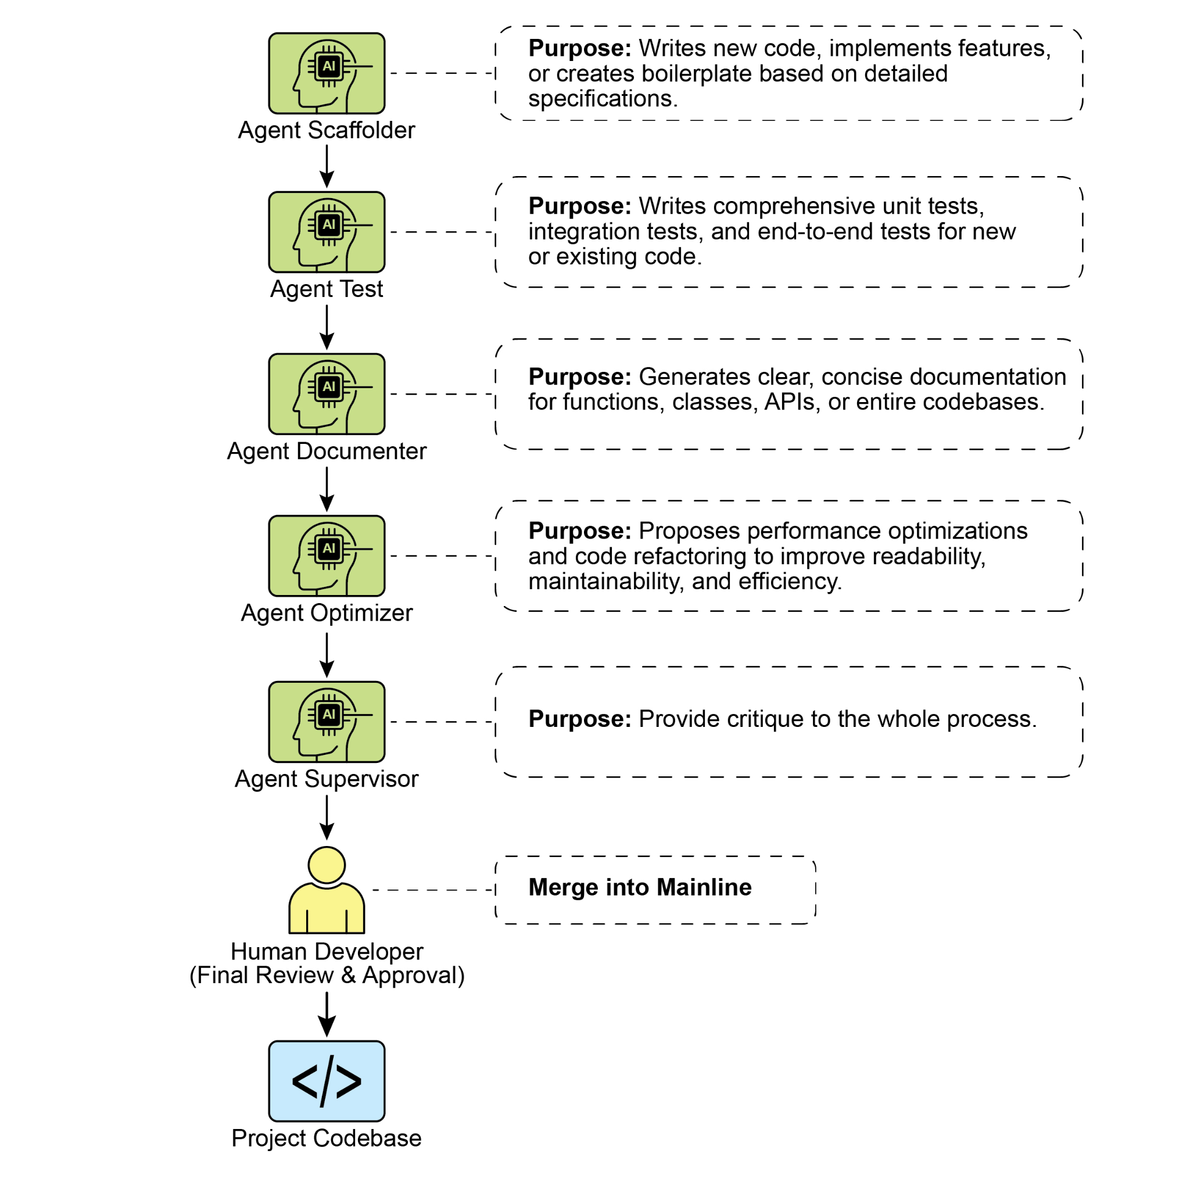

Fig. 1: Coding Specialist Examples

## Principles for Leading the Augmented Team

Successfully leading this framework requires evolving from a sole contributor into the lead of a human-AI team, guided by the following principles:

* **Maintain Architectural Ownership** Your role is to set the strategic direction and own the high-level architecture. You define the "what" and the "why," using the agent team to accelerate the "how." You are the final **arbiter** of design, ensuring every component aligns with the project's long-term vision and quality standards.
* **Master the Art of the Brief** The quality of an agent's output is a direct reflection of the quality of its input. Master the art of the brief by providing clear, unambiguous, and comprehensive context for every task. Think of your prompt not as a simple command, but as a complete briefing package for a new, highly capable team member.
* **Act as the Ultimate Quality Gate** An agent's output is always a proposal, never a command. Treat the Reviewer Agent's feedback as a powerful signal, but you are the ultimate quality gate. Apply your domain expertise and project-specific knowledge to validate, challenge, and approve all changes, acting as the final guardian of the codebase's integrity.
* **Engage in Iterative Dialogue** The best results emerge from conversation, not monologue. If an agent's initial output is imperfect, don't discard it—refine it. Provide corrective feedback, add clarifying context, and prompt for another attempt. This iterative dialogue is crucial, especially with the Reviewer Agent, whose "Reflection" output is designed to be the start of a collaborative discussion, not just a final report.

# Conclusion

The future of code development has arrived, and it is augmented. The era of the lone coder has given way to a new paradigm where developers lead teams of specialized AI agents. This model doesn't diminish the human role; it elevates it by automating routine tasks, scaling individual impact, and achieving a development velocity previously unimaginable.

By offloading tactical execution to Agents, developers can now dedicate their cognitive energy to what truly matters: strategic innovation, resilient architectural design, and the creative problem-solving required to build products that delight users. The fundamental relationship has been redefined; it is no longer a contest of human versus machine, but a partnership between human ingenuity and AI, working as a single, seamlessly integrated team.

# References

1. AI is responsible for generating more than 30% of the code at Google <https://www.reddit.com/r/singularity/comments/1k7rxo0/ai_is_now_writing_well_over_30_of_the_code_at/>
2. AI is responsible for generating more than 30% of the code at Microsoft <https://www.businesstoday.in/tech-today/news/story/30-of-microsofts-code-is-now-ai-generated-says-ceo-satya-nadella-474167-2025-04-30>